


Tips for Finding Job Applicants

Write a clear description of your business
- Always be recruiting
  - Competitor staff - who could you recruit?
  - Eligibility list is an inventory of qualified people who have applied before and may be qualified to fill future similar vacancies. An eligibility list can be either: prequalified applicants who have been tested and interviewed; or, resumes of applicants.
  - Exit interview to find out what you, as an employer, do better for the next employee. Why did they leave? What would have encouraged them to stay?
  - Culture is defined by who you hire, fire, and reward. Make sure yours is compelling. Wages, opportunity for growth/advancement, safe work environments, access to child/elder care, healthcare, tuition reimbursement, flexible schedules, remote work, paid time off and more are all reasons for staying, moving on or not re-entering the workforce. Create a culture employees want to join.

Write a clear job description
  - Contact the following to get free help analyzing and writing a job description:
www.careeronestop.org/LocalHelp/AmericanJobCenters/find-american-job-centers.aspx
  - Job Description Writer Tool:
www.careeronestop.org/BusinessCenter/Toolkit/GettingStarted.aspx?newsearch=true
  - Overview of position.
  - Duties and responsibilities.
  - Clear description of ideal candidate.
  - Qualifications and certification:
    - Minimum vs preferred
    - Can new hires get a certification on the job?
  - Work environment requirements e.g. “must be able to lift 30 lbs.” are a great way to avoid illegal questions about age, ability, and health status.

Targeted recruiting
  - Internal website.
  - Company social media platforms.
  - Ask good employees to invite friends to apply.
  - Ask your clients how they are getting employees.
  - Ask new employees how they found out about the position.
  - Professional organizations.
  - Look at competitor listings to ensure you are in line and look for inspiration on how to do better.
  - Look at 2nd Chance opportunity programs working with workers with prison records, older and disabled populations, apprenticeship programs and other ignored/under-utilized populations.

IdahoSBDC.org



Posted recruiting
  - Newspaper
  - City / Region boards e.g. “Boisejobs.com” “Betterpocatellojobs.com”
  - See job board services and prices table below. Don’t be afraid to use multiple platforms.

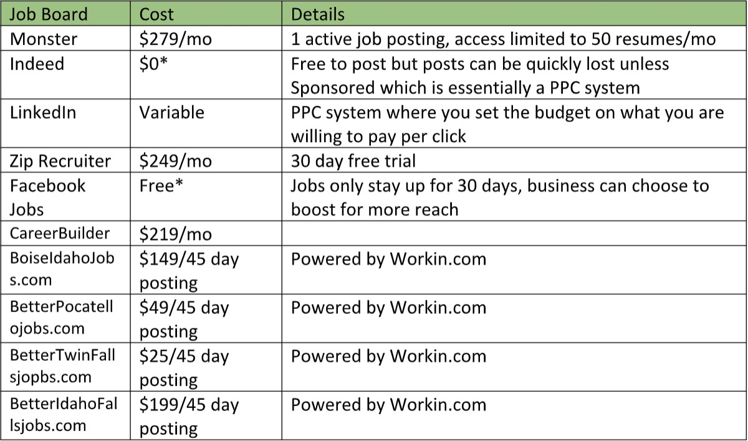
Costs are subject to change; above prices are as of June 2021.

College / University Job Boards
  - ISU employer hiring link is: https://isu.joinhandshake.com/login
  - Boise State: https://www.boisestate.edu/career/handshake-students-alumni/
  - CWI: https://cwi.edu/current-students/online-career-resource
  - College of Idaho: https://alumni.collegeofidaho.edu/page/jobs-2021
  - LCSC: https://www.lcsc.edu/student-employment/employer-resources
  - CSI: https://careers.csi.edu/careerCenter/posting-a-job.asp

Department of Labor
  - Post jobs and view resumes for free. https://idahoworks.gov/ada/r

Old-Fashioned Signage
  - Post a tidy, classy notice in your window or at point of sale. Remember, you are advertising yourself as much as looking for help!

Temp Agency
- Head Hunter
  - These are industry-specific and are starting to branch out of white-collar jobs.
Employees are no longer a replaceable commodity but a valuable resource.

annswan@isu.edu | (208) 244-8521 | IdahoSBDC.org | ISU College of Business

IdahoSBDC.org

