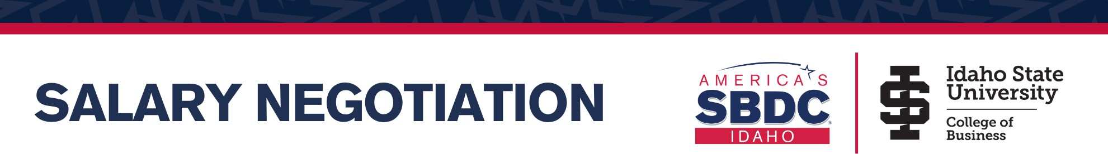



Find Objective Data and accurately research your marketplace value. You own documented accomplishments.

Salary.com gives you an approximate salary range. Find your location and best-fit job description. Identify your minimum, target, and bolstering range. Note that total compensation includes benefits.


It’s important to prepare beforehand and have a strategy. Below are important tips to craft an effective salary negotiation:

- Start negotiating your salary AFTER you get the job offer.

- Avoid being the first to mention salary or name a number. Do not make an ultimatum offer.

- Keep the negotiation objective, not personal. Do not make comparisons with others.

- Secure the offer in writing so you have a record of the interaction.

- Consider the value of benefits or benefit packages and weigh that into the overall offer.

Below are some great salary negotiation resources:
- Salary.com
- Paycheckcity.com
- Careercontessa.com
- ISU.edu/career
Make and use notes in practice, as well as real negotiations. For best negotiation results, prepare and do your research in advance. Practice interview questions and salary negotiation.

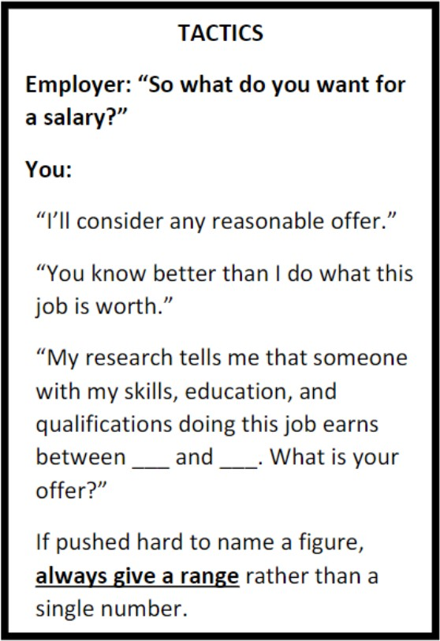

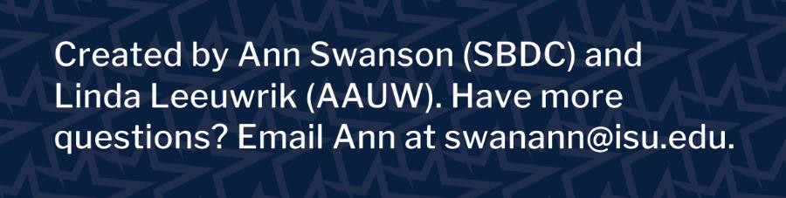

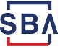
The Idaho Small Business Development Center (Idaho SBDC) is partially funded by the U.S. Small Business Administration. It operates in partnership with the SBA, Boise State University, and other funding sources. The support given by SBA through such funding does not constitute an expressed or implied endorsement of the co- sponsor's or participant's opinions, products or services. All programs are offered on a nondiscrimination basis. Reasonable accommodations for persons with disabilities will be made, if requested at least two weeks in advance. Contact Kim Sherman-Labrum, 208.426.1612. Reproduction by permission. Updated 9/10/20.

