Affiliate Faculty of Environmental Engineering


Solomon Leung, Ph.D., P.E.

Professor, Civil and Environmental Engineering, leunsolo@isu.edu Coordinator of M.S. Environmental Engineering Program
Research interests: Physicochemical treatments and design of water and wastewater, environmental risk assessment, applications of nanotechnology and nanotoxicity, sustainable and green engineering.


Karl De Jesus, Ph.D.

Professor and Former Chair, Chemistry, dejekarl@isu.edu

Research interests: Organosilane chemistry, stereoselective synthetic methodology, design and synthesis of cancer cell androgenic receptor targets for Boron Neutron Capture Therapy.

James Groome, Ph.D.

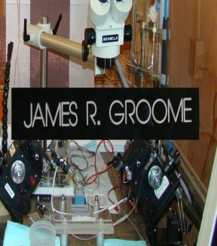
Associate Professor, Biological Sciences, groojame@isu.edu President, Snake River Association of Neuroscience
Research interests: Ion channels and neurotransmitter receptors of the nervous system, heart, and skeletal muscle: structure to function relationships of channels and receptors in mutations causing diseases such as myotonia, periodic paralysis, arrhythmia and epilepsy, computer modeling of electrical signaling dysfunction in disease; homology modeling to predict effective therapeutic drug interactions with ion channel and receptor targets.


James Wolper, Ph.D.

Professor, Mathematics, wolpjame@isu.edu

Research interests: Professor Wolper's research focus is on algebraic geometry and its applications. Recent projects include "Real–time Airborne Estimation of Atmospheric Parameters."

Marco P. Schoen, Ph.D., P.E.

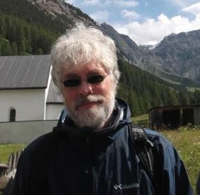
Professor and Former Chair, Mechanical Engineering, schomarc@isu.edu

Research interests: Control, vibration, system modeling, intelligent systems, and estimation applied to topics in biomedical and aerospace engineering. Recent projects addressed hybridization of Tabu Search (TS) and particle Swarm based optimization algorithms and optimum input design for parameter estimation.

James Lai, Ph.D.


Professor and Former Assistant Chair, Biomedical and Pharmaceutical Sciences,
laijame@isu.edu

Research interests: Nanotoxicology; nanopore transport of biomolecules; Neurotoxicity and metabolism of metals, ammonia, and fatty acids, with particular relevance to cell injury and cell death mechanisms in neurodegenerative, neurological and psychiatric diseases that give rise to dementia and memory disorders; Anticancer drug discovery; cancer prevention; cancer cell metabolism
and signaling; Environmental toxicity of metals, especially manganese, cadmium, and aluminum; Regulation and compartmentation of brain intermediary metabolism, especially in relation to transmitter (glutamate, aspartate, GABA, acetylcholine) synthesis & metabolism, and the associated second messengers; Glutathione transport and metabolism; functional roles of glutathione and other antioxidants; Communications between the mitochondrial and nuclear genomes in mammalian cells; Hypoxia and brain metabolism and metabolic adaptation; and Temporal lobe epilepsy: mechanisms that lead to elevation of extracellular brain glutamate.

Revised: 8/16/2017

