Appendix D: Building Specific Details

Important Notification:
(Pages 1-24 of this document can be found by accessing the Emergency Action Base Plan)

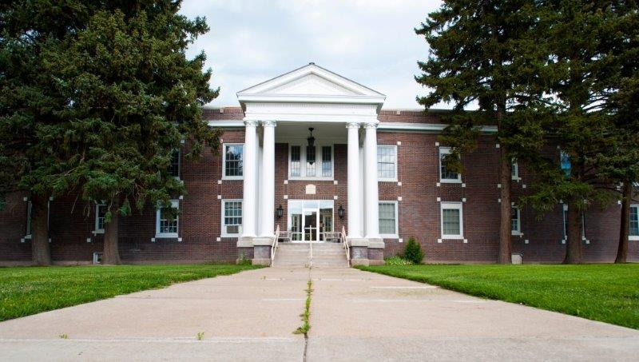

Colonial Hall
Building Number: 35
Type: Special Area of Interest

Address: 720 S. 8th Ave.

Additional information: Colonial Hall is home to the main offices for the College of Science and Engineering, along with the faculty offices for the Department of Engineering.

Contact Personnel

Report Emergencies to the Department of Public Safety at (208) 282-2515.
Name | Office Location | ISU Ext. # | Email | Area of Responsibility
Bruce Savage |  | 3131 | brucesavage@isu.edu | Safety Liaison
Chan Blackett |  | 2903 | chanblackett@isu.edu | Safety Liaison
 |  |  |  | 1st Floor Monitor
 |  |  |  | 1st Floor Monitor Alternate
 |  |  |  | 2nd Floor Monitor
 |  |  |  | 2nd Floor Monitor Alternate
 |  |  |  | 3rd Floor Monitor
 |  |  |  | 3rd Floor Monitor Alternate
 |  |  |  | 4th Floor Monitor
 |  |  |  | 4th Floor Monitor Alternate

*Public Safety has alternative contact information for employees for after hour emergencies.

Floor Monitor Entrance Assignments
Floor Monitors are assigned to an entrance to make sure everyone is exiting as they should be and possibly avoiding doors they shouldn’t be using.

1st Floor Monitor ………...… (Insert Entrance Description)
2nd Floor Monitor ………...…(Insert Entrance Description)
3rd Floor Monitor ………...…(Insert Entrance Description)
4th Floor Monitor ………...… (Insert Entrance Description)

Available Life Safety Equipment

Automated External Defibrillator (AED): There is NOT an AED located in this building.

Fire extinguisher(s): This building has 5 fire extinguishers. Located as follows:
- 1 in the Basement
- 2 on the Main Level
- 2 on the 2nd Level

Basic First aid kit: Is a basic First Aid Kit available?

Individuals with Disabilities or Special Needs

Buddy System Option: Individuals with a disability may choose to inform colleagues of any special assistance that may be required in the event of an emergency or emergency evacuation (i.e., hearing the alarm, guidance during the alarm, etc.).

Voluntary Self Identification: For individuals who have special needs, concerns, or may require assistance during an evacuation, please reach out to Disability Services at 208-282-3599.

Area of Rescue: Buildings with elevator access have designated Areas of Rescue. These areas are marked inside the building and identified on evacuation maps inside each building. Individuals with mobility issues who cannot safely evacuate from the building should assemble in the nearest Area of Rescue to wait for additional assistance from responding officials.

Area of Assembly

Evacuees should go southeast to Area of Assembly Zone 8. Zone 8 is on the west side of the R05 parking lot, adjacent to E Lovejoy St.

Access To Online Map: Colonial Hall

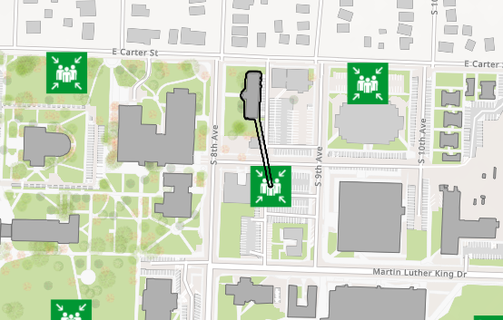

Evacuation Maps

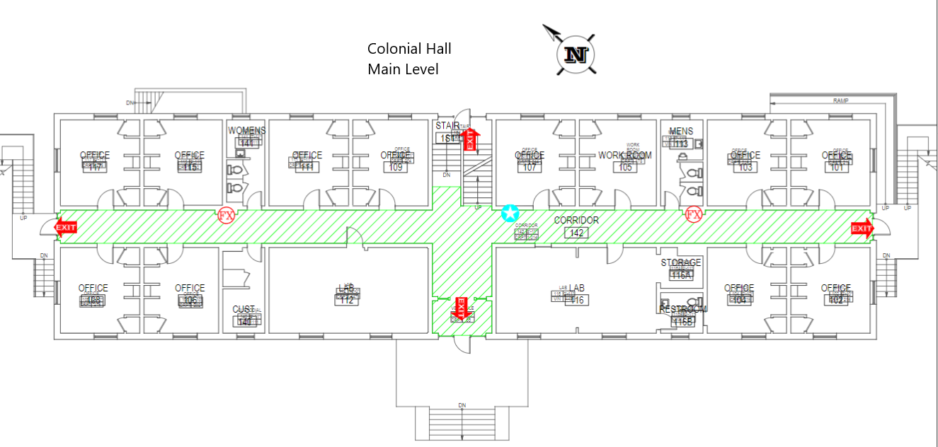
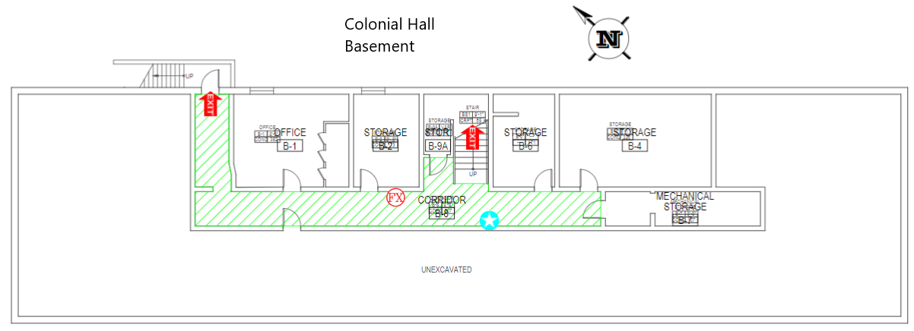

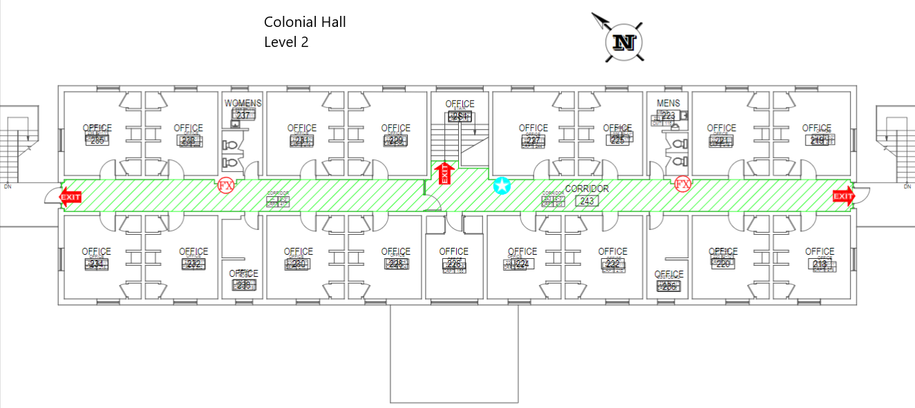



Emergency Management
Department of Public Safety
625 East Humbolt Street | Pocatello, Idaho 83209-8140
(208) 282-2515 | emergencymanagement@isu.edu

