Appendix D: Building Specific Details

Important Notification:
(Pages 1-24 of this document can be found by accessing the Emergency Action Base Plan)
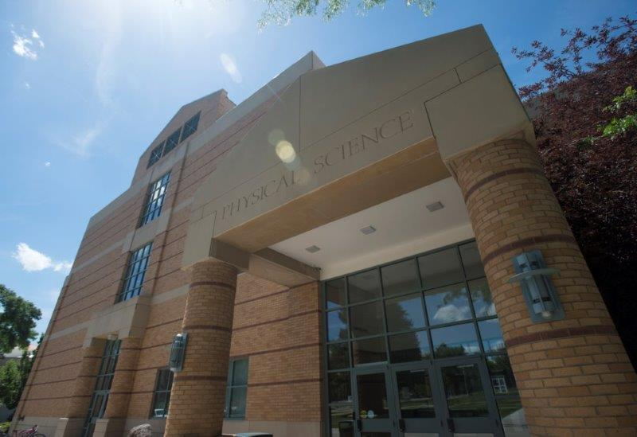

Physical Science Complex
Building Number: 3 Physical Science
3A Chemistry
Type: Education

Address: 785 S 8th Ave

Additional information: The Physical Sciences Complex houses several classrooms, laboratories and offices, and is home to the Departments of Mathematics, Physics, Geosciences and Chemistry. The building is operated on two different fire alarms that operate independent of the other. For this reason, plans include personnel contacts from each side of the building.
When entering the building from the main entrance, Mathematics, Physics and Geosciences entrance is to the right. The Environmental Health Safety & Sustainability department is also located in this section. Chemistry is accessed using the left side of the main entrance.

Contact Personnel

Report Emergencies to the Department of Public Safety at (208) 282-2515.

Physical Science

Name | Office Location | ISU Ext. # | Email | Area of Responsibility
Steve Shropshire |  | 2212 | steveshropshire@isu.edu | Building Coordinator
Jasmyne Jensen |  | 2350 | jasmynejensen@isu.edu | 1st Floor Safety Liaison
Joseph Crupper |  | 3365 | josephcrupper@isu.edu | 2nd Floor Safety Liaison
Amy Avila |  | 4197 | amyavila@isu.edu | 3rd Floor Safety Liaison
 |  |  |  | 1st Floor Monitor
 |  |  |  | 1st Floor Monitor Alternate
 |  |  |  | 2nd Floor Monitor
 |  |  |  | 2nd Floor Monitor Alternate
 |  |  |  | 3rd Floor Monitor
 |  |  |  | 3rd Floor Monitor Alternate
*Public Safety has alternative contact information for employees for after hour emergencies.

Floor Monitor Entrance Assignments
Floor Monitors are assigned to an entrance to make sure everyone is exiting as they should be and possibly avoiding doors they shouldn’t be using.

1st Floor Monitor ………...… (Insert Entrance)
2nd Floor Monitor ………...…(Insert Entrance)
3rd Floor Monitor ………...…(Insert Entrance)
Basement Floor Monitory ………...… (Insert Entrance)

Chemistry
Name | Office Location | ISU Ext. # | Email | Area of Responsibility
Lorie Kalivas | PSC 3A 151 | 4280 | loriekalivas@isu.edu | Building Coordinator
Andy Holland | PSC 3A 351/145B | 4278 | andyholland@isu.edu | Assistant Bldg. Coordinator
Scott Pristupa | PSC 3A 152 | 2436 | scottpristupa@isu.edu | 1st Floor Monitor
JD Lloyd | PSC 3A 145 | 4444 | jdlloyd@isu.edu | Safety Liaison
Enouri Omar | PSC 3A 244 | 4707 | enouriomar@isu.edu | 2nd Floor Monitor
Andrew Bernard | PSC 3A 243 | 3422 | andrewbernard@isu.edu | 2nd Floor Monitor
Cori Jenkins | PSC 3A 347 | 3734 | corijenkins@isu.edu | 3rd Floor Monitor
Leslie Nickerson | PSC 3A 361 | 2668 | leslienickerson@isu.edu | 3rd Floor Monitor
Lewis Burnam | N/A | N/A | lewisburnam@isu.edu | 4th Floor Monitor
 |  |  |  | 4th Floor Monitor Alternate

*Public Safety has alternative contact information for employees for after hour emergencies.

Floor Monitor Entrance Assignments

1st Floor Monitor ………...… [South Central Entrance]
2nd Floor Monitor ………...…[South Stairwell Access]
3rd Floor Monitor ………...… [South Stairwell Access]
4th Floor Monitor ………...… [North Entrance]

Floor Monitors are assigned to an entrance to make sure everyone is exiting as they should be and possibly avoiding doors they shouldn’t be using.

Available Life Safety Equipment

Automated External Defibrillator (AED): Is located on on the Chemistry side of the building (entrance to the left) in the main hall by Chemistry Office (Room 145)

Narcan: One is located on the first floor by Lobby 161

Fire extinguisher(s):

Physical Science (3) has 38 fire extinguishers, located in hallways, rooms, and laboratories:
- 19 on the basement level
- 7 on the first floor
- 7 on the second floor
- 5 on the third floor

Basic First aid kit: Is a basic First Aid Kit available?

Chemistry (3A) has 51 fire extinguishers, located in both hallways, rooms, and laboratories:
- 2 on the basement level
- 20 on the first floor
- 13 on the second floor
- 14 on the third floor
- 2 on the fourth floor

Basic First aid kit: A basic first aid kit is kept in every laboratory and stockroom.

Individuals with Disabilities or Special Needs

Buddy System Option: Individuals with a disability may choose to inform colleagues of any special assistance that may be required in the event of an emergency or emergency evacuation (i.e., hearing the alarm, guidance during the alarm, etc.).

Voluntary Self Identification: For individuals who have special needs, concerns, or may require assistance during an evacuation, please reach out to Disability Services at 208-282-3599.

Area of Rescue: Buildings with elevator access have designated Areas of Rescue. These areas are marked inside the building and identified on evacuation maps inside each building. Individuals with mobility issues who cannot safely evacuate from the building should assemble in the nearest Area of Rescue to wait for additional assistance from responding officials.

Area of Assembly

Evacuees should go west to Area of Assembly Zone 11. Zone 11 is on the grass west of the Physical Science Complex, adjacent to E Carter St.

Access to Online Map: Physical Science Complex
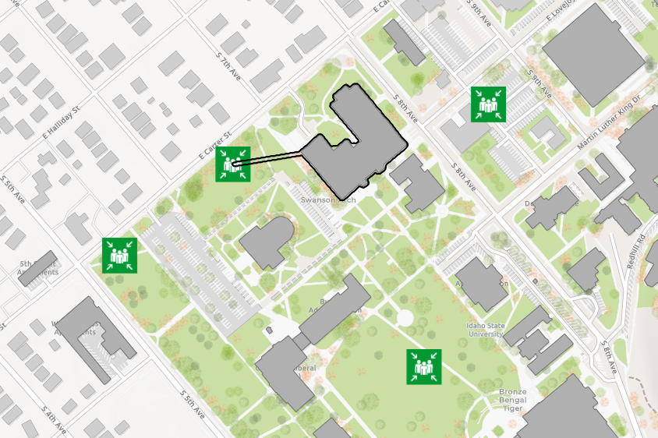

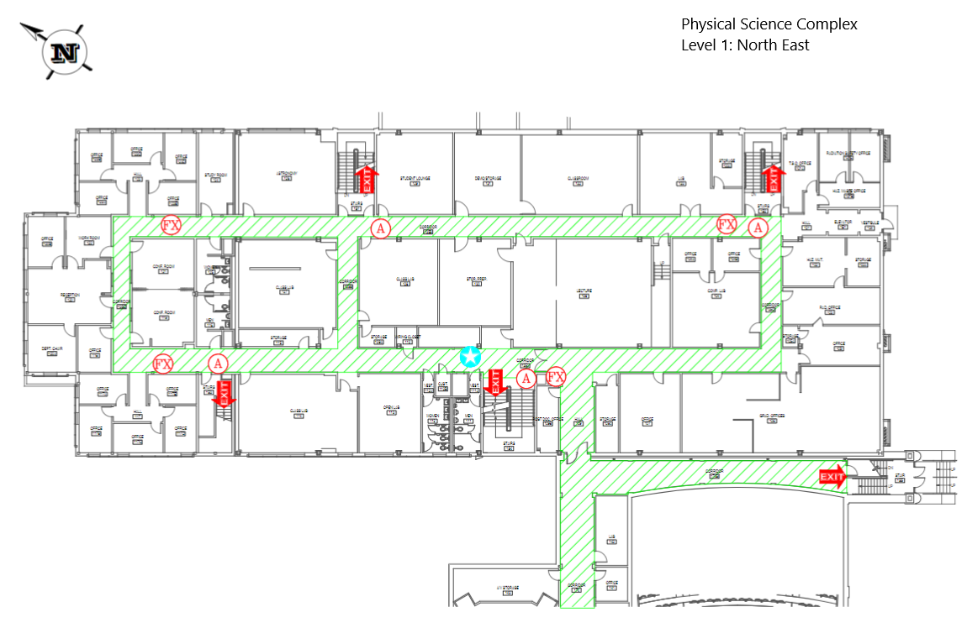
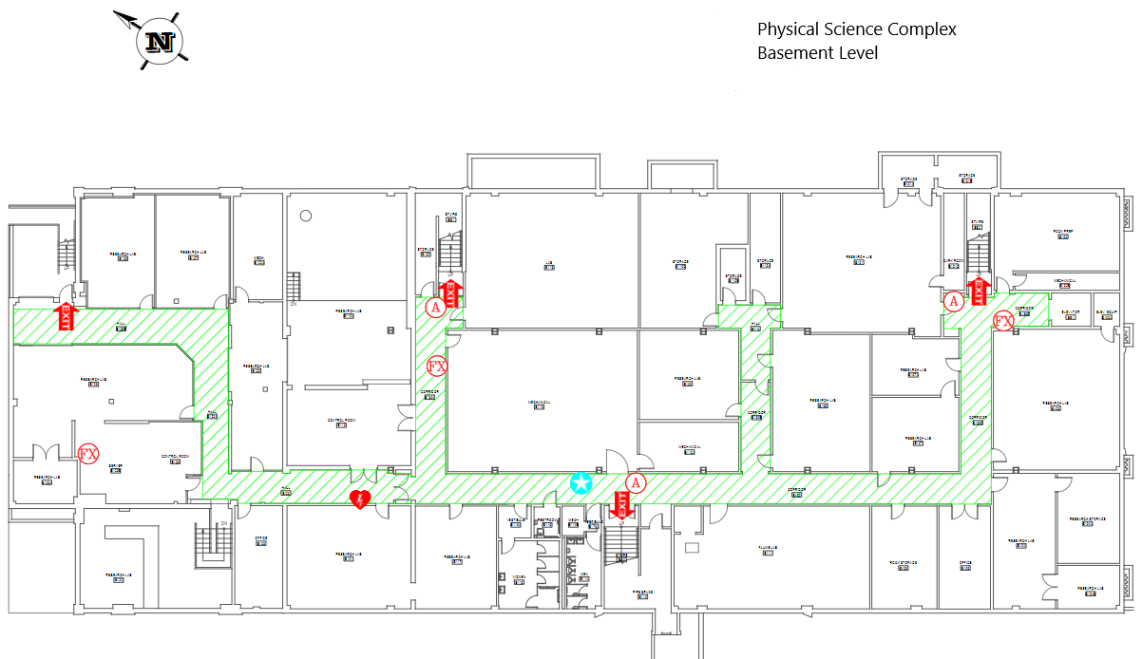
Evacuation Maps
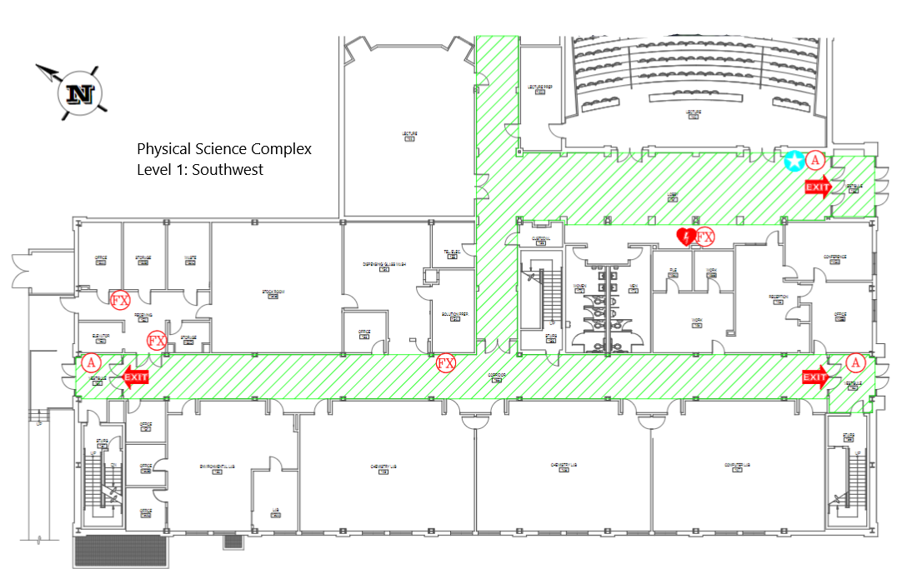
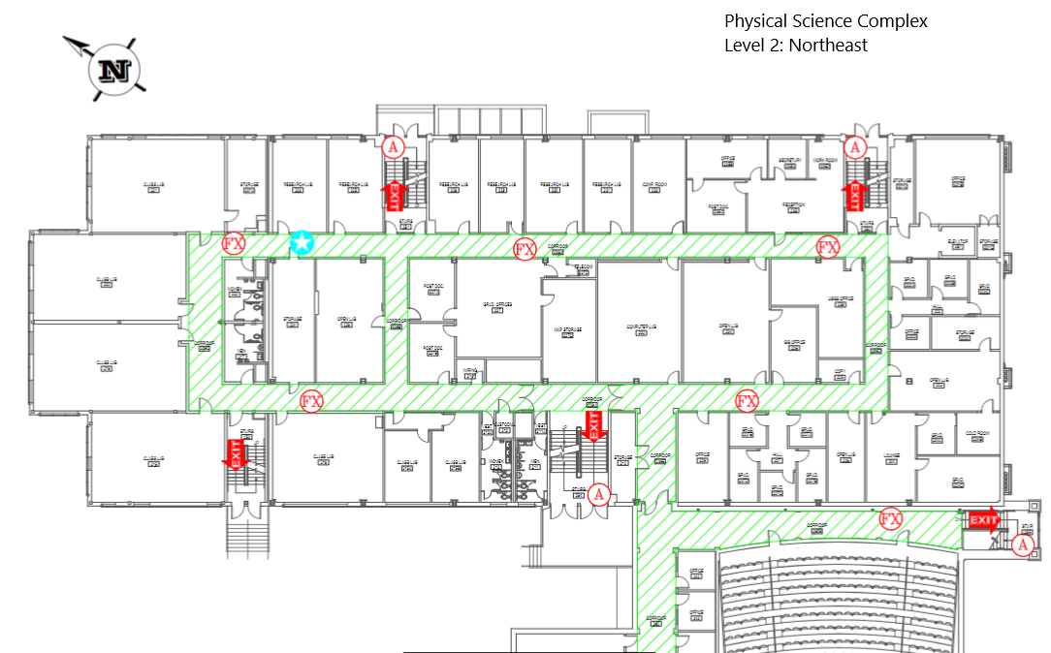
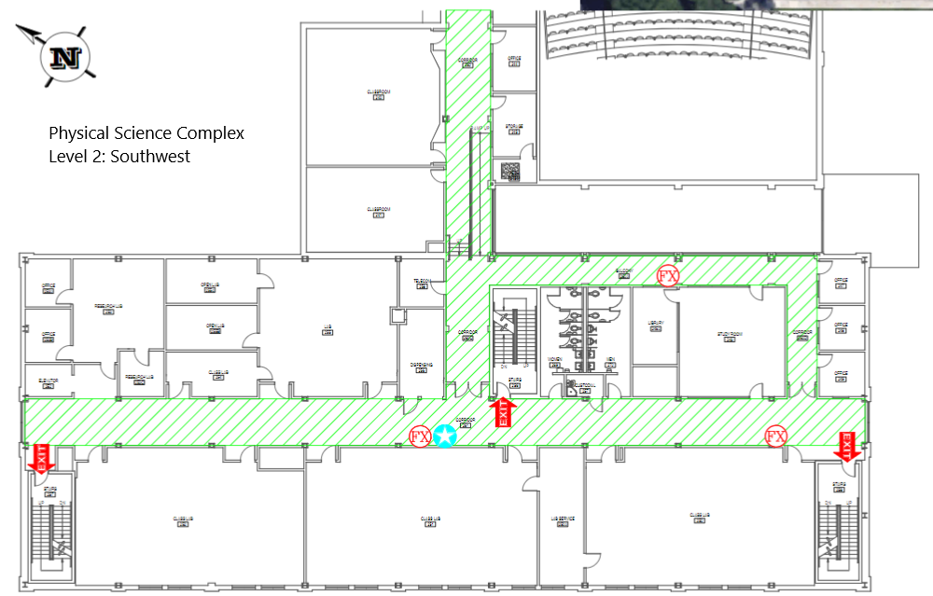
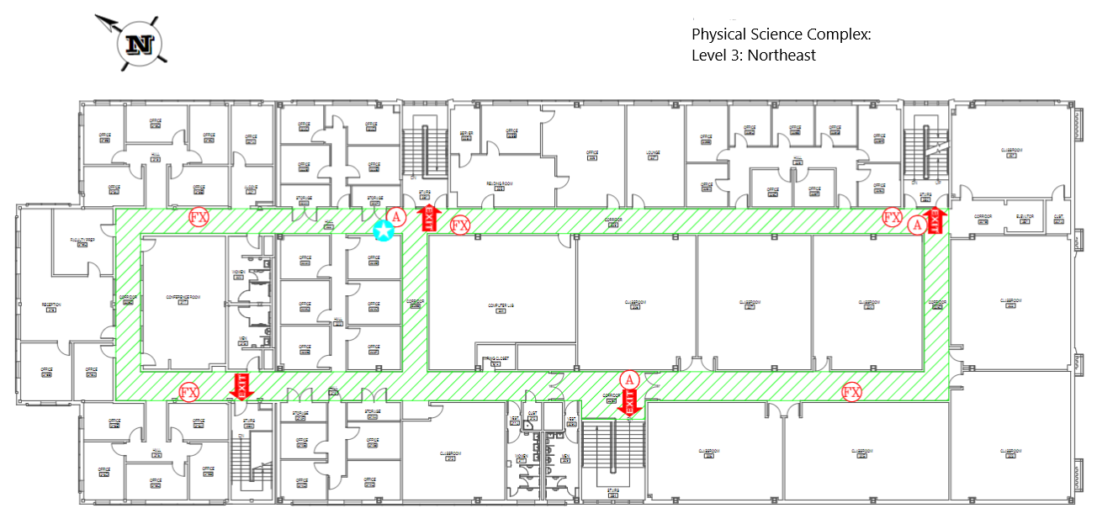

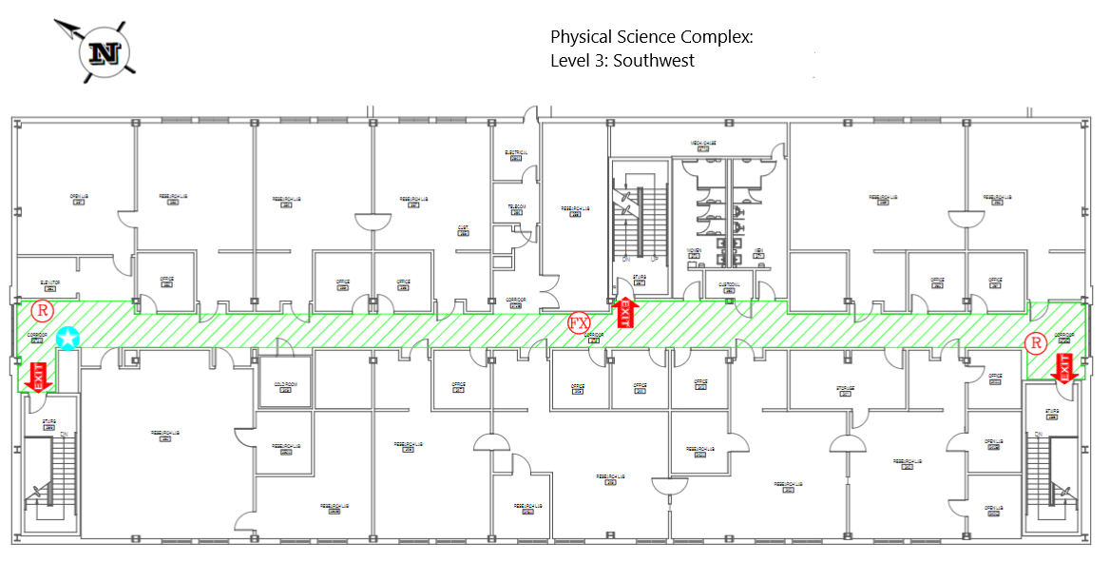



Emergency Management
Department of Public Safety
625 East Humbolt Street | Pocatello, Idaho 83209-8140
(208) 282-2515 | emergencymanagement@isu.edu

