Appendix D: Building Specific Details

Important Notification:
(Pages 1-24 of this document can be found by accessing the Emergency Action Base Plan)

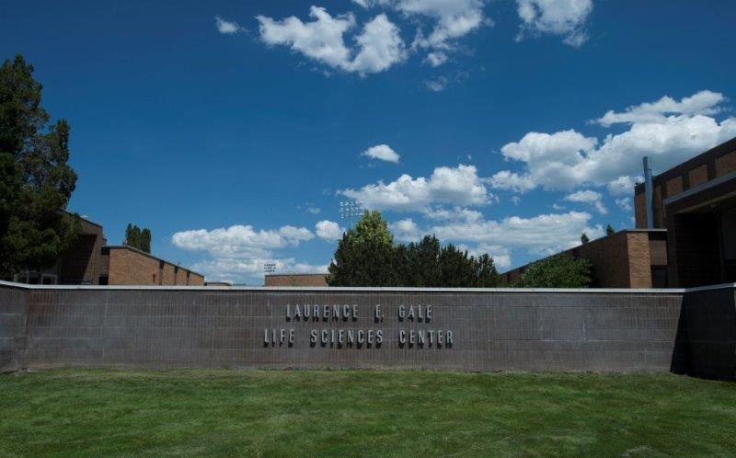

Gale Life Science (Biology)
Building Number: 65
Type: Education

Address: 660 Memorial Drive

Additional information: The Gale Life Sciences Building houses several laboratories and offices for the Department of Biology.

Contact Personnel

Report Emergencies to the Department of Public Safety at (208) 282-2515.
Name | Office Location | ISU Ext. # | Email | Area of Responsibility
Dawn Stoddard | GLS 192 | 4418 | dawnstoddard@isu.edu | Building Coordinator
Janet Loxterman | GLS 230 | 4150 | janetloxterman@isu.edu | Asst. Building Coordinator
Shannon Porath | GLS 182 | 3895 | nettmia@isu.edu | 1st Floor Monitor
Stockroom Lab Assistant  On shift | GLS 193 | 4418 | biologys@isu.edu | 1st Floor Monitor (Alt)
Anna Iasonides | GLS 227 | 4150 | iasoanna@isu.edu | 2nd Floor Monitor
Chelsea Wilkerson |  | 2758 | chelseawilkerson@isu.edu | Safety Liaison
Bree Gilbert | GLS 202 | 5761 | breeanngilbert@isu.edu | 3rd Floor Monitor
Juanita Gonzalez | GLS 202 | 3524 | juanitagonzalez@isu.edu | 3rd Floor Monitor (Alt)
Lisa McDougall | GLS 461 | 4148 | lisamcdougall@isu.edu | 4th Floor Monitor
 |  |  |  | 4th Floor Monitor (Alt)

*Public Safety has alternative contact information for employees for after hour emergencies.

Floor Monitor Entrance Assignments
Floor Monitors are assigned to an entrance to make sure everyone is exiting as they should be and possibly avoiding doors they shouldn’t be using.

1st Floor Monitor ………...… (Insert Entrance Description)
2nd Floor Monitor ………...…(Insert Entrance Description)
3rd Floor Monitor ………...…(Insert Entrance Description)
4th Floor Monitor ………...… (Insert Entrance Description)

Available Life Safety Equipment

Automated External Defibrillator (AED): There is NOT an AED located in this building.

Narcan: One is located on the first floor by room 263

Fire extinguisher(s): This building has 76 fire extinguishers. Located as follows:
- 19 in the basement
- 14 on the main level
- 16 on the second floor
- 22 on the third floor
- 2 on the fourth floor

Basic First aid kit: A basic first aid kit is kept in the Stockroom.

Individuals with Disabilities or Special Needs

Buddy System Option: Individuals with a disability may choose to inform colleagues of any special assistance that may be required in the event of an emergency or emergency evacuation (i.e., hearing the alarm, guidance during the alarm, etc.).

Voluntary Self Identification: For individuals who have special needs, concerns, or may require assistance during an evacuation, please reach out to Disability Services at 208-282-3599.

Area of Rescue: Buildings with elevator access have designated Areas of Rescue. These areas are marked inside the building and identified on evacuation maps inside each building. Individuals with mobility issues who cannot safely evacuate from the building should assemble in the nearest Area of Rescue to wait for additional assistance from responding officials.

Area of Assembly

Evacuees should go south to Area of Assembly Zone 4. Zone 4 is on the grass west of the H09 parking lot, adjacent to Memorial Dr.

Access to Online Map: Gale Life Sciences

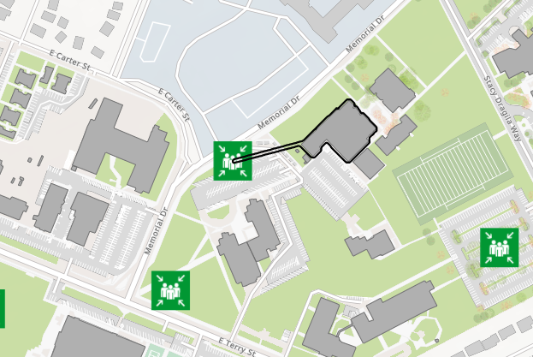

Evacuation Maps
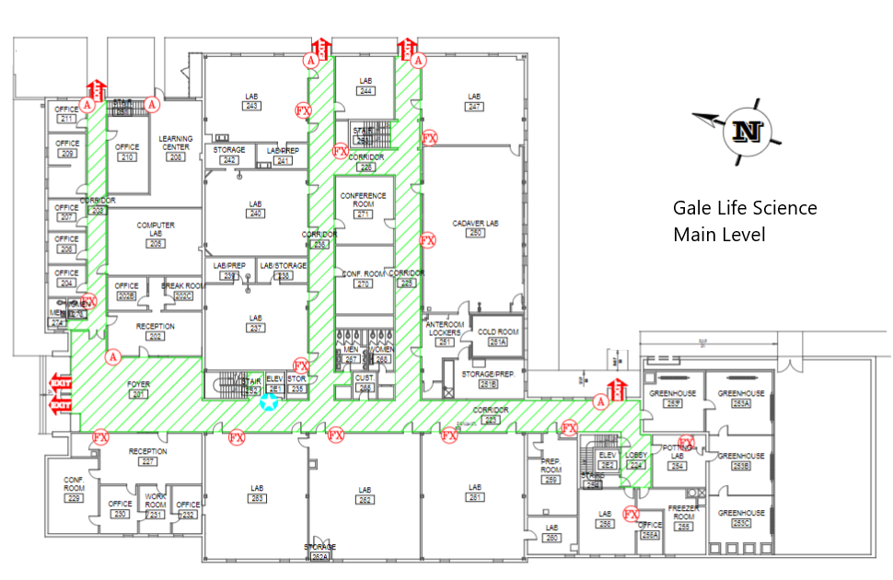
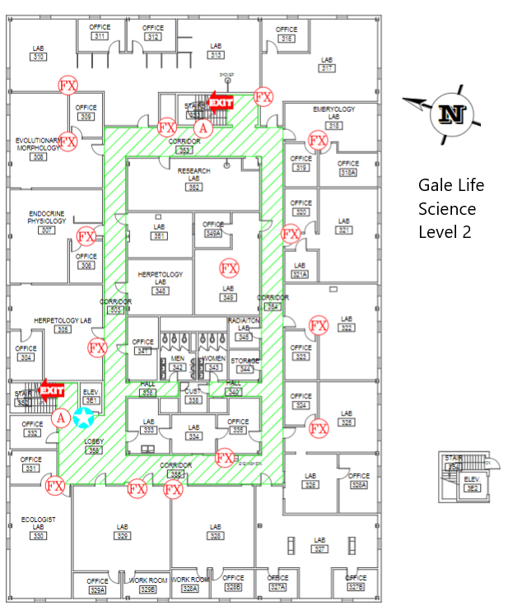

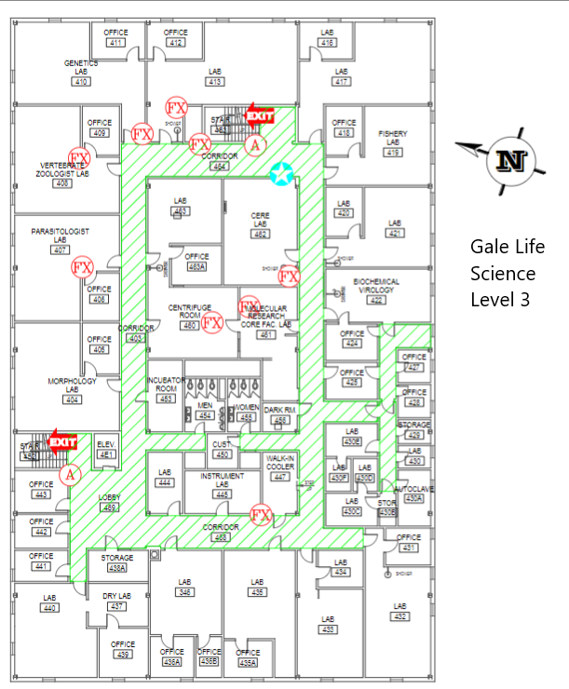

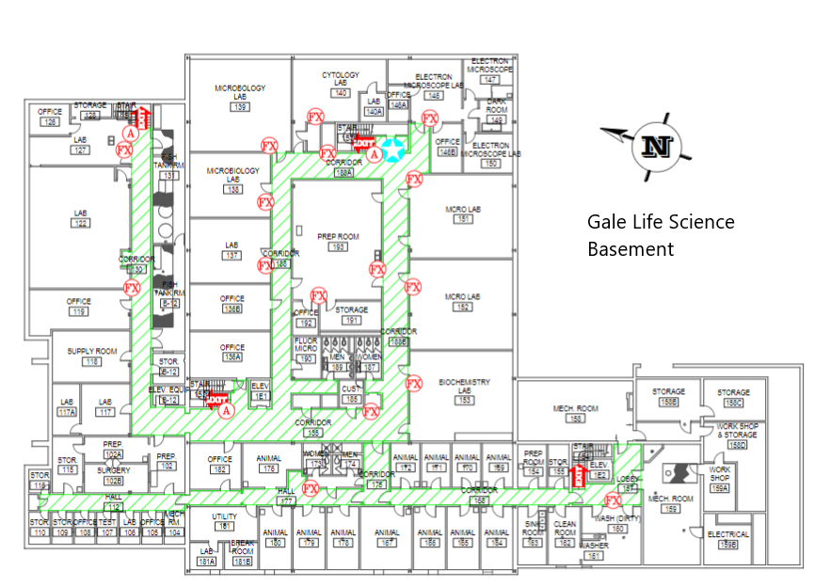



Emergency Management
Department of Public Safety
625 East Humbolt Street | Pocatello, Idaho 83209-8140
(208) 282-2515 | emergencymanagement@isu.edu

