Appendix D: Building Specific Details

Important Notification:
(Pages 1-24 of this document can be found by accessing the Emergency Action Base Plan)

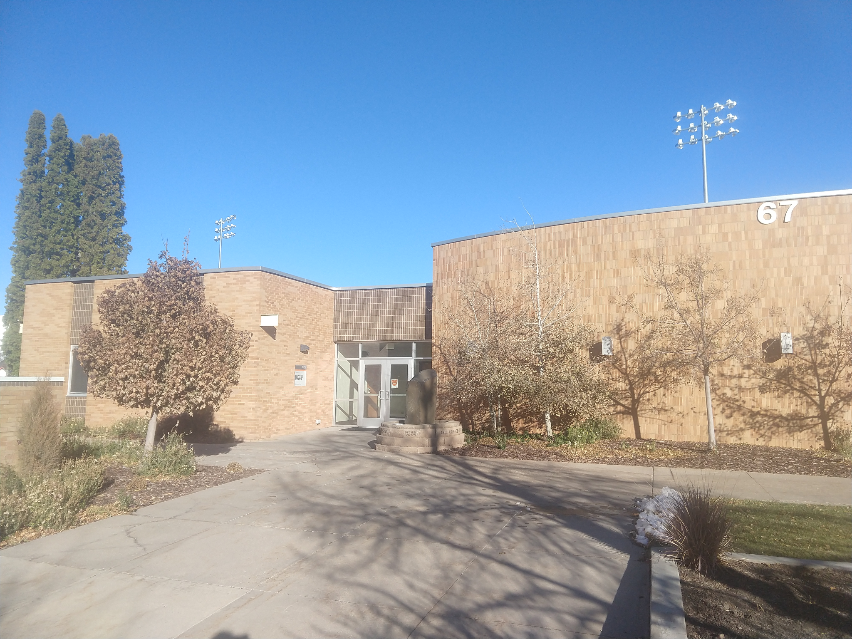

Lecture Center
Building Number: 67
Type: Education

Address: 640 Memorial Drive

Additional information:

Contact Personnel

Report Emergencies to the Department of Public Safety at (208) 282-2515.
Name | Office Location | ISU Ext. # | Email | Area of Responsibility
Erin Miller |  | 4418 | erinmiller@isu.edu | Building Coordinator
Janet Loxterman |  | 4150/6167 | janetloxterman@isu.edu | Assistant Bldg. Coordinator
 |  |  |  | 1st Floor Monitor
 |  |  |  | 1st Floor Monitor Alternate
 |  |  |  | 2nd Floor Monitor

*Public Safety has alternative contact information for employees for after hour emergencies.

Floor Monitor Entrance Assignments
Floor Monitors are assigned to an entrance to make sure everyone is exiting as they should be and possibly avoiding doors they shouldn’t be using.

1st Floor Monitor ………...… (Insert Entrance Description)
2nd Floor Monitor ………...…(Insert Entrance Description)
3rd Floor Monitor ………...…(Insert Entrance Description)
4th Floor Monitor ………...… (Insert Entrance Description)

Available Life Safety Equipment

Automated External Defibrillator (AED): There is NOT an AED located in this building.

Fire extinguisher(s): This building has 4 fire extinguishers on the main floor, located as follows:
- North Hall Firebox
- North Hall Mech Room
- South Hall Firebox
- South Hall Mech Room

Basic First aid kit: Is a basic First Aid Kit available?

Individuals with Disabilities or Special Needs

Buddy System Option: Individuals with a disability may choose to inform colleagues of any special assistance that may be required in the event of an emergency or emergency evacuation (i.e., hearing the alarm, guidance during the alarm, etc.).

Voluntary Self Identification: For individuals who have special needs, concerns, or may require assistance during an evacuation, please reach out to Disability Services at 208-282-3599.

Area of Rescue: Buildings with elevator access have designated Areas of Rescue. These areas are marked inside the building and identified on evacuation maps inside each building. Individuals with mobility issues who cannot safely evacuate from the building should assemble in the nearest Area of Rescue to wait for additional assistance from responding officials.

Area of Assembly

Evacuees should go northwest to Area of Assembly Zone 2. Zone 2 is in the center of the Sports Med field (west of the Sports & Orthopedic Center and east of Memorial Dr.).

Access to Online Map: Lecture Center

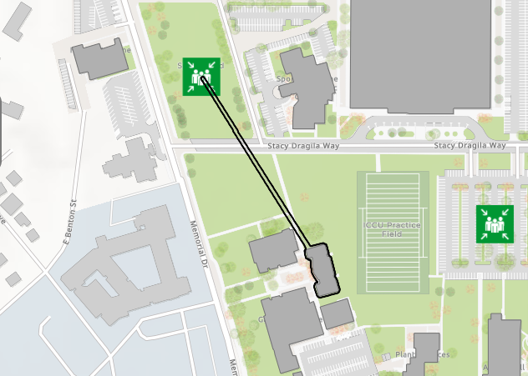

Evacuation Maps

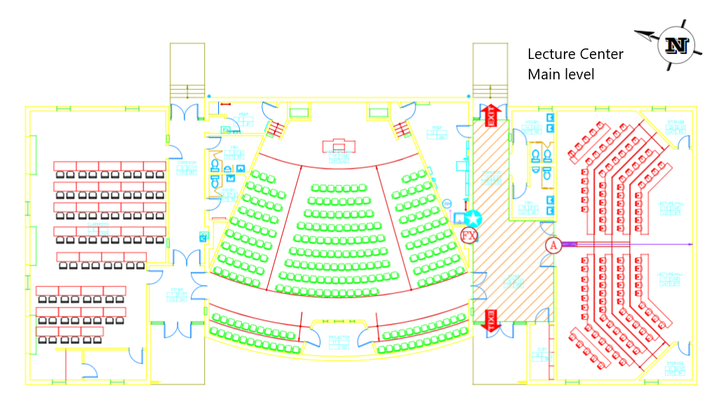
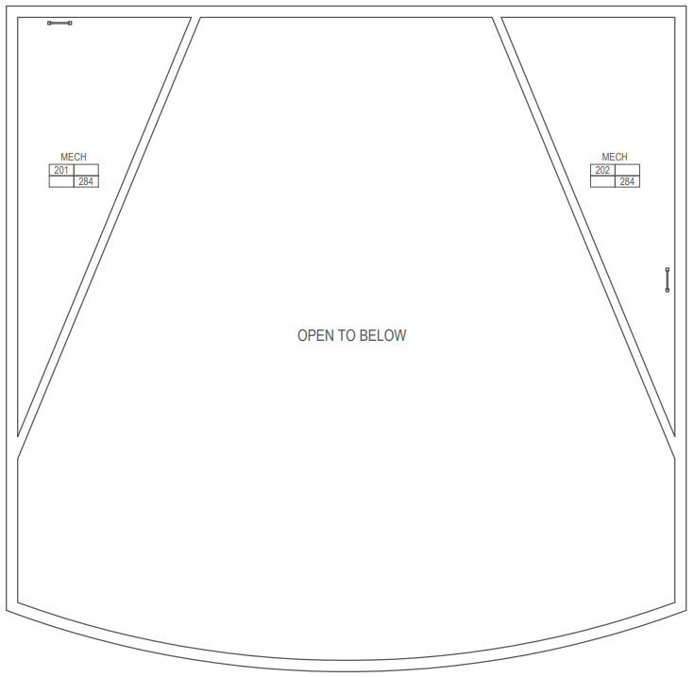

Level 2



Emergency Management
Department of Public Safety
625 East Humbolt Street | Pocatello, Idaho 83209-8140
(208) 282-2515 | emergencymanagement@isu.edu

