Appendix D: Building Specific Details

Important Notification:
(Pages 1-24 of this document can be found by accessing the Emergency Action Base Plan)

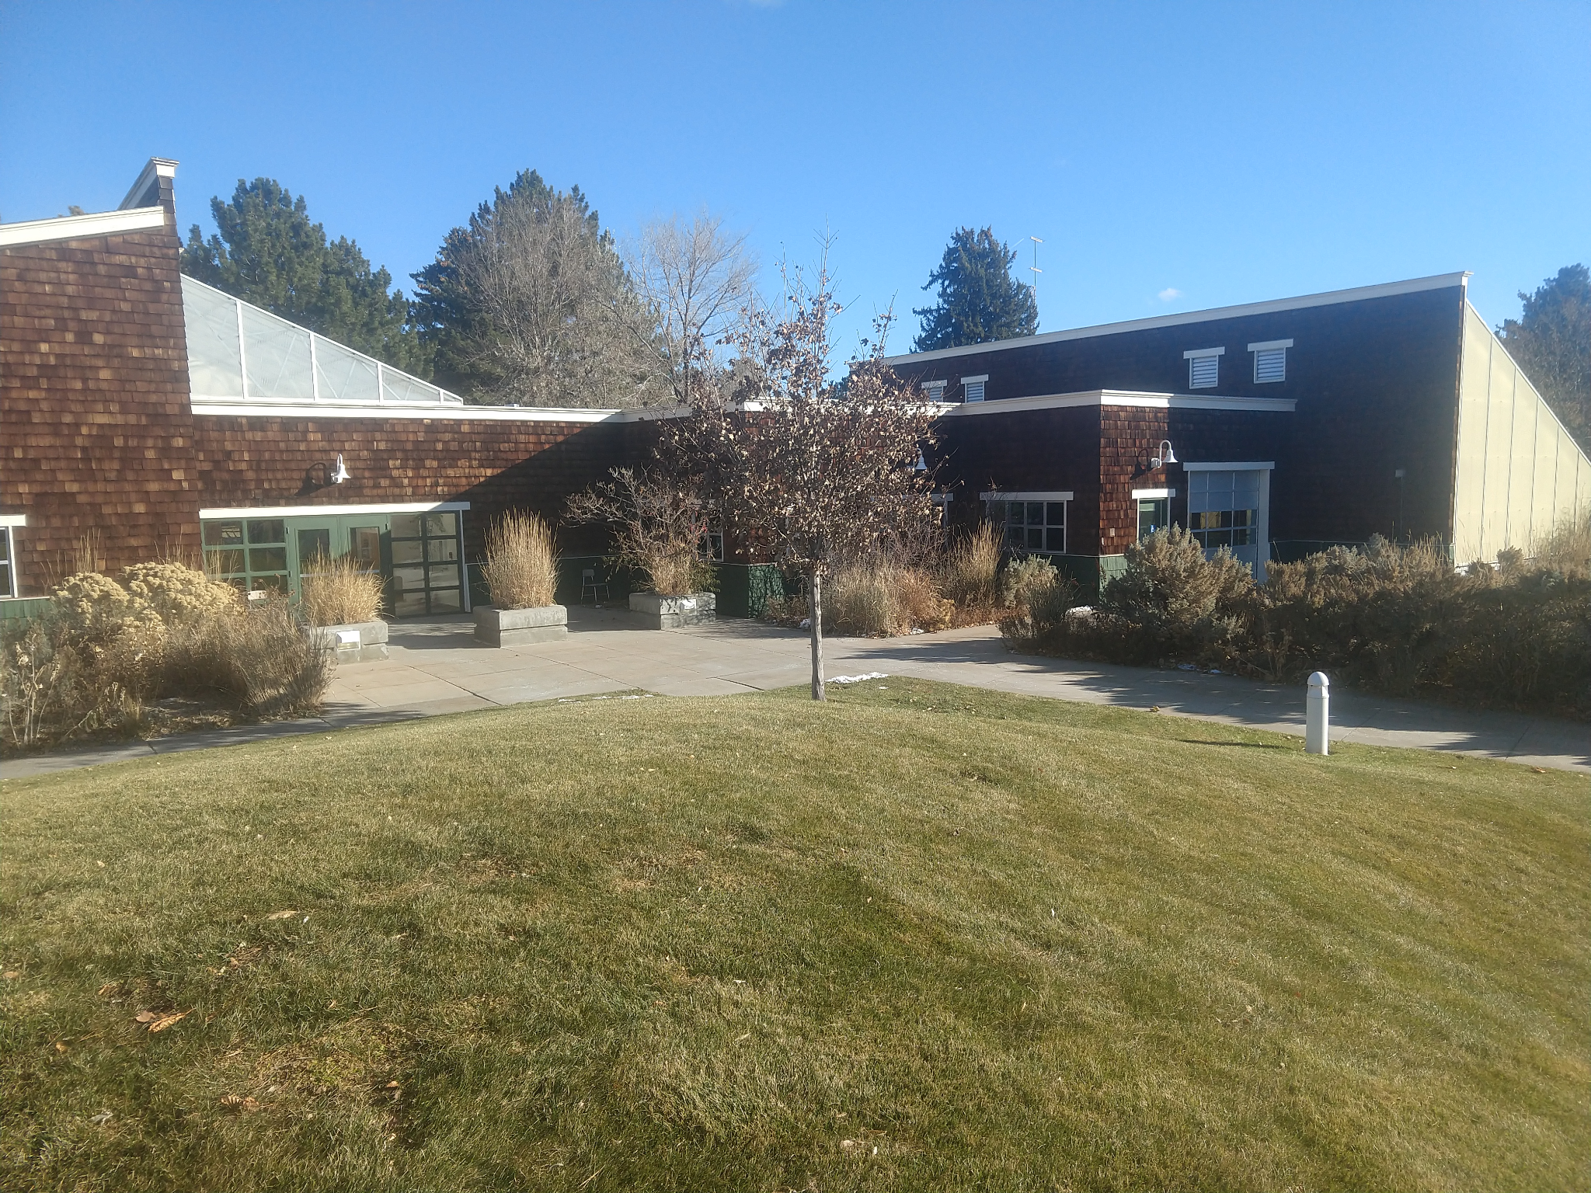

Plant Sciences
Building Number: 69
Type: Education

Address: 650 Memorial Drive

Additional information:

Contact Personnel

Report Emergencies to the Department of Public Safety at (208) 282-2515.
Name | Office Location | ISU Ext. # | Email | Area of Responsibility
Sunshine Denney | GLS Greenhouse | 4776 | dennsuns@isu.edu | Building Coordinator
Erin Miller | GLS 192 | 4418 | milleri5@isu.edu | Assistant Bldg. Coordinator

*Public Safety has alternative contact information for employees for after hour emergencies.

Floor Monitor Entrance Assignments
Floor Monitors are assigned to an entrance to make sure everyone is exiting as they should be and possibly avoiding doors they shouldn’t be using.

1st Floor Monitor ………...… North Entrance
2nd Floor Monitor ………...…North Entrance
3rd Floor Monitor ………...…Front Entrance
4th Floor Monitor ………...… South Entrance

Available Life Safety Equipment

Automated External Defibrillator (AED): There is NOT an AED located in this building.

Fire extinguisher(s): This building has 3 fire extinguishers. Located on the main floor as follows:
- By Room 104
- West Entry in Box
- West Entry in Box

Basic First aid kit: A basic first aid kit is kept in the hallway, attached to the wall.

Individuals with Disabilities or Special Needs

Buddy System Option: Individuals with a disability may choose to inform colleagues of any special assistance that may be required in the event of an emergency or emergency evacuation (i.e., hearing the alarm, guidance during the alarm, etc.).

Voluntary Self Identification: For individuals who have special needs, concerns, or may require assistance during an evacuation, please reach out to Disability Services at 208-282-3599.

Area of Rescue: Buildings with elevator access have designated Areas of Rescue. These areas are marked inside the building and identified on evacuation maps inside each building. Individuals with mobility issues who cannot safely evacuate from the building should assemble in the nearest Area of Rescue to wait for additional assistance from responding officials.

Area of Assembly

Evacuees should go north to Area of Assembly Zone 3. Zone 3 is in the center of the G13 parking lot (east of the ICCU Practice Field and south of Stacy Dragila Way).

Access to Online Map: Plant Sciences

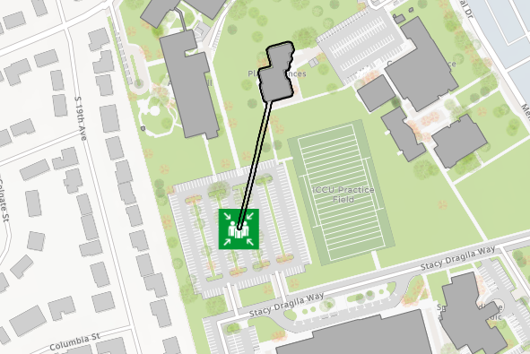

Evacuation Maps

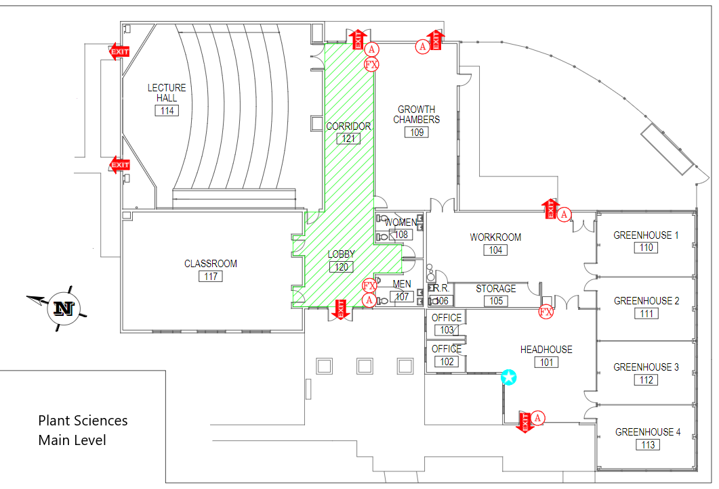



Emergency Management
Department of Public Safety
625 East Humbolt Street | Pocatello, Idaho 83209-8140
(208) 282-2515 | emergencymanagement@isu.edu

