Appendix D: Building Specific Details

Important Notification:
(Pages 1-24 of this document can be found by accessing the Emergency Action Base Plan)

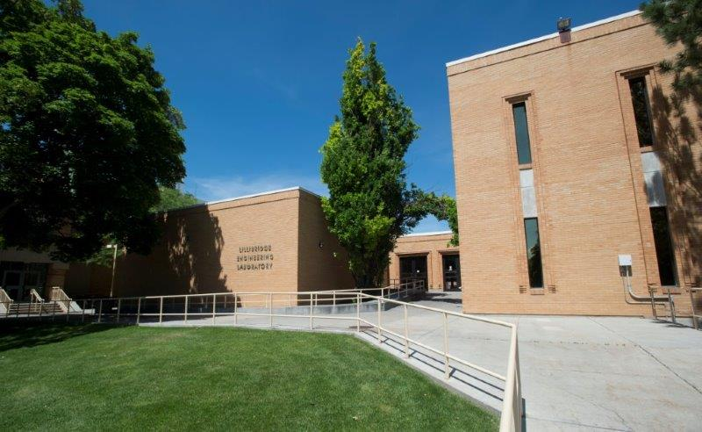

Lillibridge Engineering
Building Number: 7
Type: Education

Address: 833 S. 8th Ave.

Additional information: The Engineering Building is home to offices, classrooms and laboratory space for the Department of Engineering.

Contact Personnel

Report Emergencies to the Department of Public Safety at (208) 282-2515.
Name | Office Location | ISU Ext. # | Email | Area of Responsibility
Chan Blackett | LEL 218 | 2902 | chanblackett@isu.edu | Building Coordinator
Chad Pope | CH 101 | 2875 | chadpope@isu.edu | Safety Liaison
Chan Blackett | LEL 218 | 2902 | chanblackett@isu.edu | 1st Floor Monitor
Staci Wheatley | LEL 224 | 2902 | staciwheatley2@isu.edu | 1st Floor Monitor Alternate
 |  |  |  | 2nd Floor Monitor
 |  |  |  | 2nd Floor Monitor Alternate
 |  |  |  | 3rd Floor Monitor
 |  |  |  | 3rd Floor Monitor Alternate
 |  |  |  | 4th Floor Monitor
 |  |  |  | 4th Floor Monitor Alternate

*Public Safety has alternative contact information for employees for after hour emergencies.

Floor Monitor Entrance Assignments
Floor Monitors are assigned to an entrance to make sure everyone is exiting as they should be and possibly avoiding doors they shouldn’t be using.

1st Floor Monitor ………...… (Enter Location of Entrance)
2nd Floor Monitor ………...…(Enter Location of Entrance)
3rd Floor Monitor ………...…(Enter Location of Entrance)

Available Life Safety Equipment

Automated External Defibrillator (AED): is located on the wall on the 1st floor located near the door of LEL 126.

Narcan: One is located on the first floor by foyer 101.

Fire extinguisher(s): This building has 19 fire extinguishers. Located as follows:
- 8 on the Basement Level
- 8 on the First Floor
- 2 on the Second Floor
- 1 on the Fifth Floor

Basic First Aid Kit: Located in the Main Engineering Office.

Individuals with Disabilities or Special Needs

Buddy System Option: Individuals with a disability may choose to inform colleagues of any special assistance that may be required in the event of an emergency or emergency evacuation (i.e., hearing the alarm, guidance during the alarm, etc.).

Voluntary Self Identification: For individuals who have special needs, concerns, or may require assistance during an evacuation, please reach out to Disability Services at 208-282-3599.

Area of Rescue: Buildings with elevator access have designated Areas of Rescue. These areas are marked inside the building and identified on evacuation maps inside each building. Individuals with mobility issues who cannot safely evacuate from the building should assemble in the nearest Area of Rescue to wait for additional assistance from responding officials.

Area of Assembly

Evacuees should go south to Area of Assembly Zone 14. Zone 14 is in the center of the Quad to the south of Lillibridge Engineering.

Access to Online Map: Lillibridge Engineering

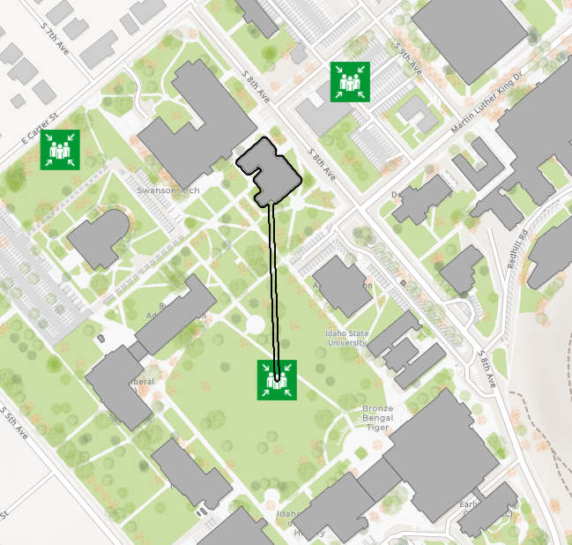

Evacuation Maps
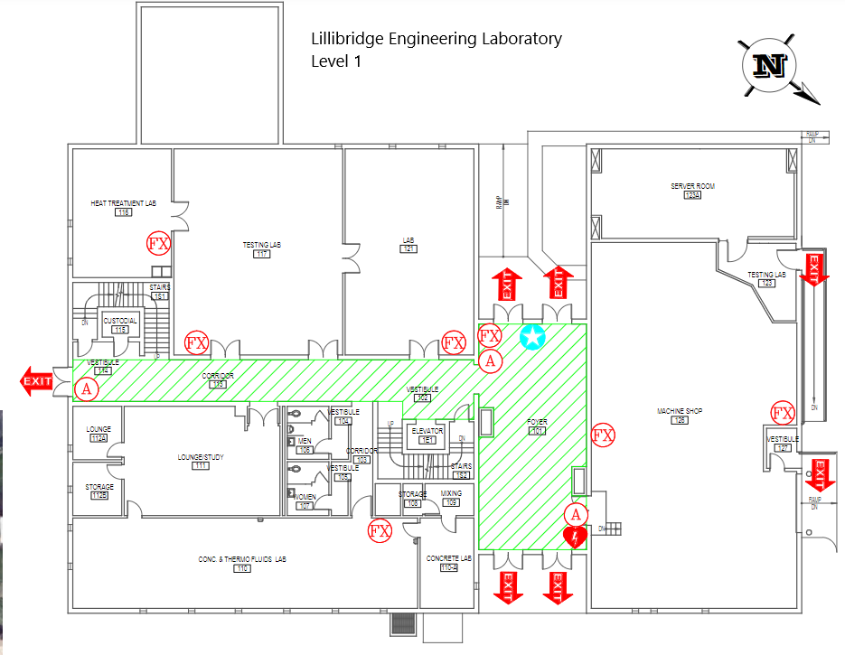

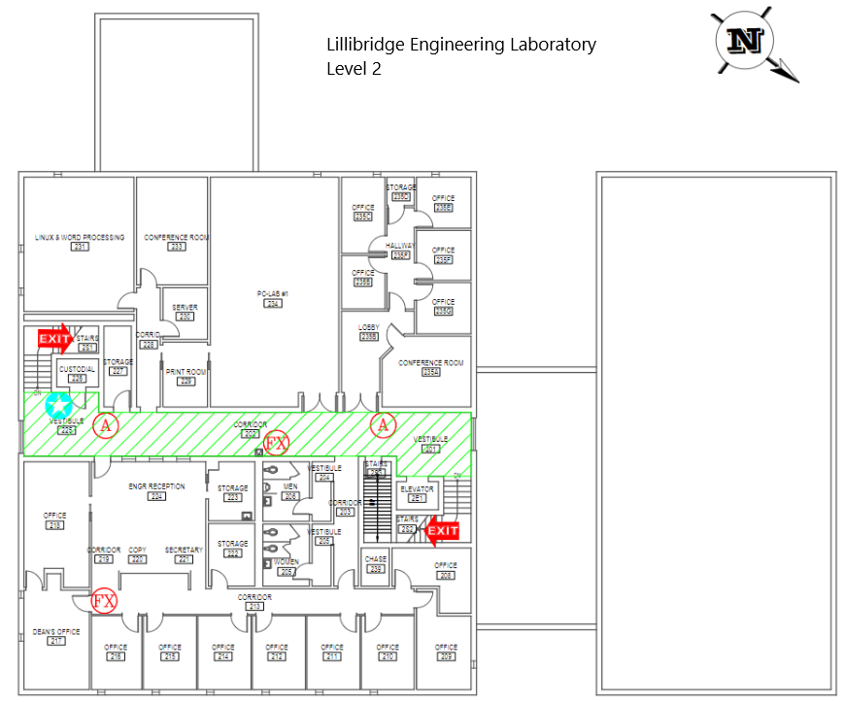

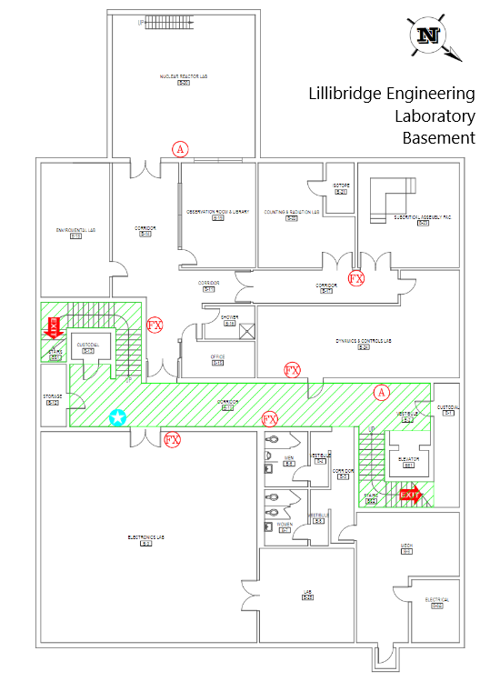



Emergency Management
Department of Public Safety
625 East Humbolt Street | Pocatello, Idaho 83209-8140
(208) 282-2515 | emergencymanagement@isu.edu

