Appendix D: Building Specific Details

Important Notification:
(Pages 1-24 of this document can be found by accessing the Emergency Action Base Plan)

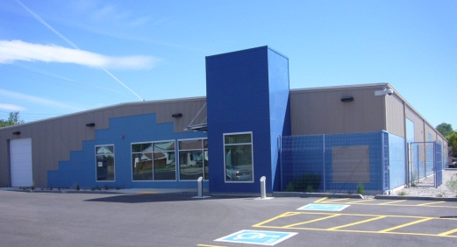

Measurement & Control Engineering Research Center (MCERC)
Building Number: 79
Type: Education

Address: 1030 S 2nd Ave

Additional information: the MCERC is an interdisciplinary state-approved research facility. There are several laboratories specializing in areas of aerospace, robotics, structures, biomedical, controls and measurement systems, energy systems, and embedded systems.

Contact Personnel

Report Emergencies to the Department of Public Safety at (208) 282-2515.

Name | Office Location | ISU Ext. # | Email | Area of Responsibility
Marco Schoen | COL 222 | 4377 | marcoschoen@isu.edu | Building Coordinator
Kellie Wilson | 101A & COL | 2902 | kelliewilson@isu.edu | Assistant Bldg. Coordinator
Jared Cantrell | MCERC 121 |  | jaredcantrell@isu.edu | Floor Monitor

*Public Safety has alternative contact information for employees for after hour emergencies.

Floor Monitor Entrance Assignments
Floor Monitors are assigned to an entrance to make sure everyone is exiting as they should be and possibly avoiding doors they shouldn’t be using.

1st Floor Monitor ………...… Rear East & West Entrances

Available Life Safety Equipment

Automated External Defibrillator (AED): There is NOT an AED located in this building

Fire extinguisher(s): This building has 12 fire extinguishers, located as follows:
- Big Bay West Side
- Big Bay East Side
- Surplus Area by Restroom
- Near Wire Spools
- By Overhead Door
- By Front Door
- Main Hall Firebox
- Firebox by Room 125
- Forklift
- Structural Lab Room 128
- Structural Dynamics Lab
- Structural Lab Room 102

Basic First aid kit: A basic first aid kit is kept in Room 102, 131, and 128.

Individuals with Disabilities or Special Needs

Buddy System Option: Individuals with a disability may choose to inform colleagues of any special assistance that may be required in the event of an emergency or emergency evacuation (i.e., hearing the alarm, guidance during the alarm, etc.).

Voluntary Self Identification: For individuals who have special needs, concerns, or may require assistance during an evacuation, please reach out to Disability Services at 208-282-3599.

Area of Rescue: Buildings with elevator access have designated Areas of Rescue. These areas are marked inside the building and identified on evacuation maps inside each building. Individuals with mobility issues who cannot safely evacuate from the building should assemble in the nearest Area of Rescue to wait for additional assistance from responding officials.

Area of Assembly

Evacuees should go north to Area of Assembly Zone 21. Zone 21 is in the center of the G03 parking lot (southwest of S 4th Ave and northwest of E Putnam St).

Access to Online Map: Measurement & Control Engineering Research Center

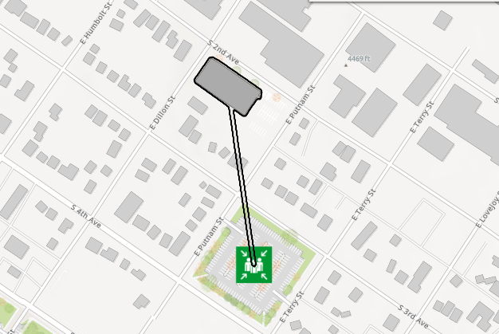

Evacuation Maps

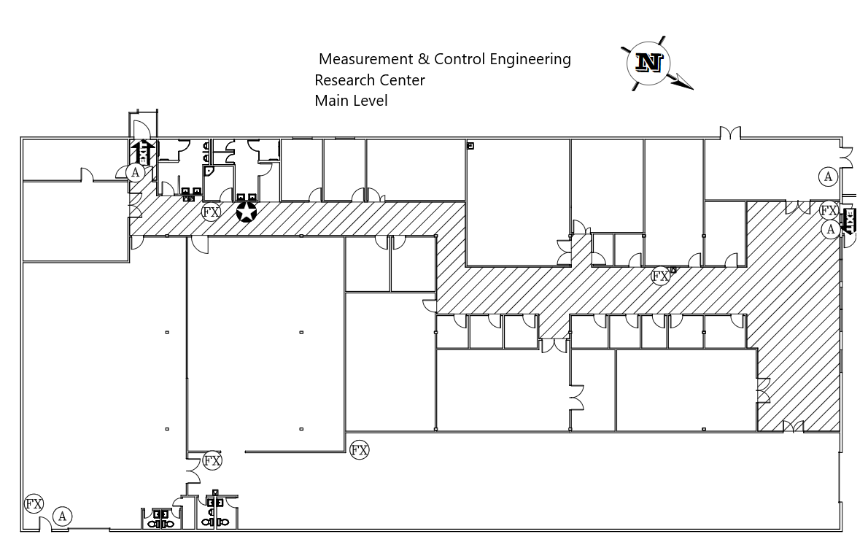



Emergency Management
Department of Public Safety
625 East Humbolt Street | Pocatello, Idaho 83209-8140
(208) 282-2515 | emergencymanagement@isu.edu

