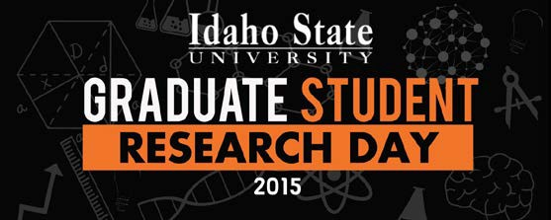
Congratulations to the 2015 Graduate Student Research Day Award Recipients!

Top Oral Presentations
Pedagogy & Writing in Multiple Modes | The Mathematical Model of Writing  Amy Brumfield
Psychology & Health | Assault-Related Shame Mediates the Association Between Reactions to Social Disclosure and Psychological Distress Christopher DeCou; Trevor Cole; Shannon Lynch; Kathleen Matthews; Maria Wong
History & Society | Bungalows and Occupation: Pocatello, 1900-1930  Kristine Hunt
Natural Science & Environmental Studies | Creating a Digital Interface for Botanical Resources  Ashelee Rasmussen
Narrative & Analysis | The Writing Cure and WWI Dream Poetry  Kelly Ricken
Pedagogy & Online Tools | The Multidimensional Instructional Efficiency of Worked Examples  Danae Romrell
Top Poster Presentations
Pedagogy, Politics, & Praxis | Borrowing for the Future: Student Perceptions of Lending Commitment  Teresa Borrenpohl
Research Across the Sciences | Another Look at Visibility: Accuracy of Judging Personal Values and Personality Traits  Jennifer McDonald; Tera Letzring
Biological & Environmental Studies | 65 Years Of Vegetation Change in the East River Basin, CO  Stephanie Zorio; Charles Williams; Ken Aho
Mental, Physical, & Emotional Health | Asbestos-Induced Pleural Fibrosis Involves Autoantibody- Mediated Protein Tyrosine Phosphorylation Pathway Robert Hanson; John Gilmer; Jean Pfau
People’s Choice Poster Award | The Phantom Gas Field Project: Evidence of Physiological Responses of Sagebrush Due to Human Noise-Induced Changes in Arthropod Herbivory  Maria Pacioretty; Elizeth Cinto Mejia; Keith Reinhardt; Jesse Barber; Marie-Anne de Graff

