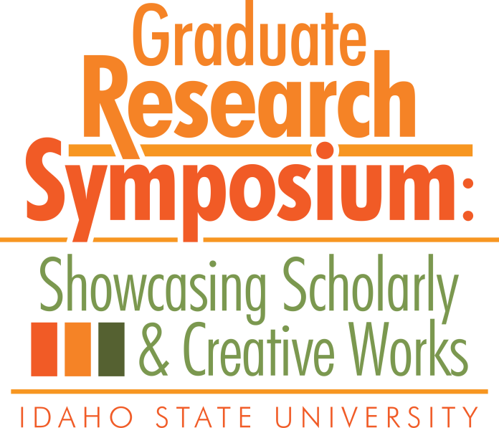

Congratulations to the

2018 Graduate Research Symposium Award Recipients!

- 3MT:
  - 1st Place: Jonathan Goode
  - 2nd Place: Nirmeet Adhvaryu
  - 2nd Place: Jessica Whitaker-Fornek

- Poster Symposium:
  - Biological & Natural Sciences: Kayla Glossner
  - Education, Learning, and Training: Leila Riley
  - Engineering, Physical, & Mathematical: Utsa Rashique
  - Health, Nutrition, & Clinical Sciences: Jeanna Ritter
  - Humanities, Behavioral, & Social Sciences: Sheherezade Krzyzaniak
  - People’s Choice Poster: Nirmeet Adhvaryu

- Oral Presentation:
  - Biological & Natural Sciences: Carolyn Macek
  - Business, Economics, and Public Administration: Hassan Afzal
  - Education, Learning & Training: Jonathan Lord
  - Engineering, Physical, and Mathematical Sciences: Landon Bayless-Edwards
  - Humanities, Behavioral, and Social Sciences: Paul Williams

