


Disability Services
Providing Equal Access
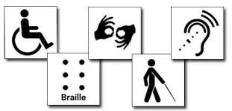
Meridian Disability Services Coordinator:
Soni Myers

Disability
A condition that substantially limits a major life activity (ADA, Federal Law).
- Examples:
  - Visual Impairment or Blind
  - Hard of Hearing or Deaf
  - Mental Health Conditions
  - Intellectual Disability
  - Learning Disability
  - Acquired Brain Injury
  - Physical and Mobility Impairments

Accommodations

Students
- Fill out the Online Student Application.
- Schedule an appt.

Employees
- Fill out the Employee Request for Services Form.
- DS will contact to schedule an appt.

www.isu.edu/disabilityservices

Communication at every stage:
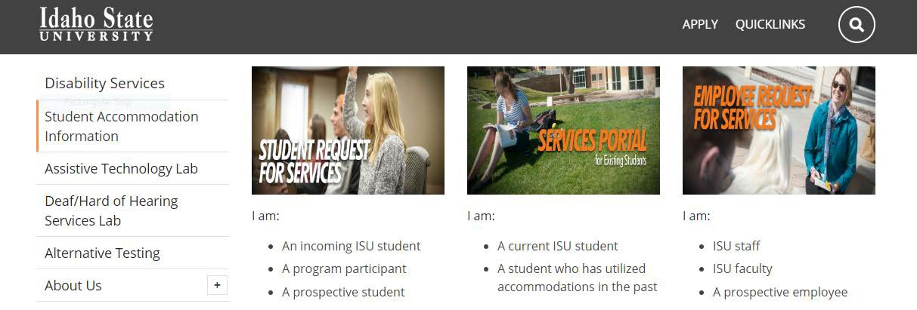
- Online
- Application
- Acceptance Letter
- Syllabus & Handbook
- NSO
- Transition from didactic to clinical
- Appeals

When to involve us?
- Student self-reports disability
- Suspect disability
- Important decisions
- Appeal process

- Identity issues

Top 5 Barriers

- Desire to avoid negative social reaction
- Insufficient knowledge
- Perceived quality and usefulness of services
- Negative experiences with professors
Marshak, L., Van Wieren, T., Raeke Ferrell, D., Swiss, L., & Dugan, C. (2010). Exploring barriers to college student use of disability services and accommodations. Journal of Postsecondary Education and Disability, 22(3), 151-165.

Case Law Example
- North v. Widener University, 869 F. Supp. 2d 630 (E.D. Penn. 2012).

What can we do?
- Provide guidance and consultation
- Support consistency
- Assist with communication
- Make determinations about reasonable accommodations

Contact
www.isu.edu/disabilityservices

Pocatello Main Office
  - Rendezvous Complex, Room 125
  - 208-282-3599
  - VP for ASL: 208-530-6505

Meridian Office
  - 208-373-1723
  - Sam & Aline Skaggs Health Science Center, Room 644b

