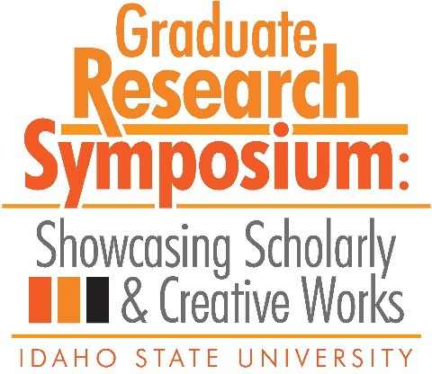

Congratulations to the 2019 Graduate Research Symposium Award Recipients!

1st Place – 3MT
Presented to
The Impact of Prior Information on Personality Judgment Accuracy
Jacob Gibson

2nd Place – 3MT
Presented to
The Oriental Superheroes: A Discussion of the Political Questions
posed in G. Willow Wilson’s Cairo: A Graphic Novel and the Ms.
Marvel comic books.
Noran Amin

3rd Place – 3MT
Presented to
A Peel Inside the Eggshell: How a Baby Bird’s
Nervous System Develops to Control Breathing
Jessica Whitaker- Fornek

People’s Choice – 3MT
Presented to
Understanding the Link Between Sleep and Suicidality:
A Preliminary Analysis of an Underlying Neuropsychological Mechanism
Stephanie McManimen

Top Oral Presentation in Biological, Physical & Natural Sciences
Presented to
Groundwater Geochemistry and Flow in the Spring Mountains, NV:
Implications for the Death Valley Regional Flow System
Sara Warix

Top Oral Presentation in Education, Learning & Training
Presented to
Real World Retention: A Qualitative Analysis of the Career Path
Internship
at Idaho State University
Staci Phelan

Top Oral Presentation in Health, Nutrition & Clinical Sciences
Presented to

Quantification of Cellular Ceramide by Targeting Sphingomyelin Synthase In Cancer Cells Utilizing Anhydrophytosphinsoine, jaspine B.
Farjan Afrin, James Lai, Srinath Pashikanti, Apurba Dutta

Top Oral Presentation in Humanities, Behavioral & Social Sciences
Presented to
Examining Political Behaviors “Power/Knowledge” through
Brave New World & Walden Two
Christopher Brown

Top Poster Presentation in Biological, Physical & Natural Sciences
Presented to
Habitability Potential of Enceladus: An Analog Study of
Lo’ihi Seamount System in Hawaii
Angela Garcia & Ashley Shields

Top Poster Presentation in Education, Learning & Training
Presented to
Professional Development in Rural Schools
Laura Sheridan

Top Poster Presentation in Health, Nutrition & Clinical Sciences

Presented to
Quantification of Cellular Ceramide by Targeting Sphingomyelin
Synthase
In Cancer Cells Utilizing Anhydrophytosphinsoine, jaspine B. Farjana Afrin, Jared Barrott, James Lai, Srinath Pashikanti, Apurba Dutta

Top Poster Presentation in Humanities, Behavioral & Social Sciences
Presented to
Are Two Methods Better Than One? Examining the Utility and
Comparability of
Metric and Morphoscopic Traits to Estimate Ancestry
Hannah Dawson

Top Poster Presentation in People’s Choice
Presented to
Metal Isotope Movement in Human Dental Tissue
Rebekah Rakowski, Samantha Blatt, Amy Michael, John Dudgeon, Kateea Peterson

