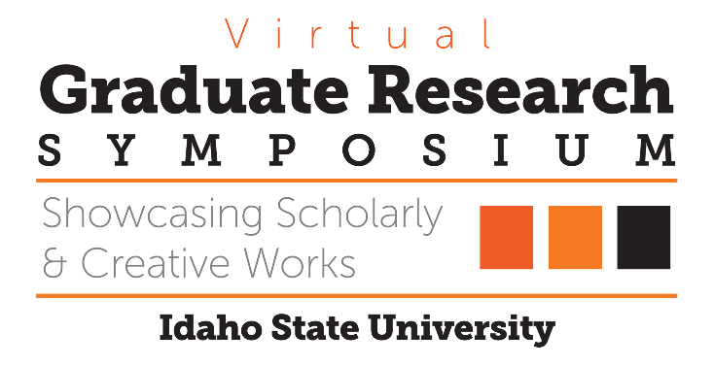

Congratulations to the 2020 Graduate Research Symposium Award Recipients!
3MT Winner
Presented to
Looking Beyond Leaves: Nutrient Leaching Potential of Seasonal
Litterfall in the Urban Forest
Sophie Hill

Top Oral Presentation in Biological, Physical & Natural Sciences
Presented to
Determining Residence Times and Sources of Groundwater and
Carbon in a Semi-Arid Basin
Sara Warix

Top Oral Presentation in Education, Learning & Training
Presented to
Scenario-based E-learning and Feedback Type Effects on Learning
and Motivation
Sacha Johnson

Top Oral Presentation in Health, Nutrition & Clinical Sciences
Presented to
Pilot Study of Functional Outcomes from a Modified Intensive
Comprehensive Aphasia Program
Thomas Gonzalez

Top Oral Presentation in Health, Nutrition & Clinical Sciences
Presented to
Shame in Supervision: Interpretative Phenomenological Analysis in
Counselor Education
William Lane

Top Oral Presentation in Humanities, Behavioral & Social Sciences
Presented to
Testing the State and Trait Accuracy Model III: The Effects of Affect
Congruence on the Accuracy of Trait and State Judgments
Sheherezade Krzyzaniak

Top Poster Presentation in Biological, Physical & Natural Sciences
Presented to
Determining Residence Times and Sources of Groundwater and
Carbon in a Semi-Arid Basin

Jennifer Souza

Top Poster Presentation in Engineering, Physical & Mathematical Sciences
Presented to
Disaster Management Robotics in collaboration with Idaho National
Laboratory (INL).
Uma Shankar Medasetti

Top Poster Presentation in Health, Nutrition & Clinical Sciences
Presented to
Bone Targeting Delivery of Small Angiotensin Peptides: A Focus on
AT2 Receptor
Arina Ranjit

Top Poster Presentation in Humanities, Behavioral & Social Sciences
Presented to
Maternal trauma, markers of HPA axis dysregulation, prenatal
depression, and breastfeeding
Lillian Bengtson

