
Editable IPLP Template
Accelerate Math Learning

** In order to edit this document you will need to make a copy and save it to your own Google Drive, or download it as a Word document. **

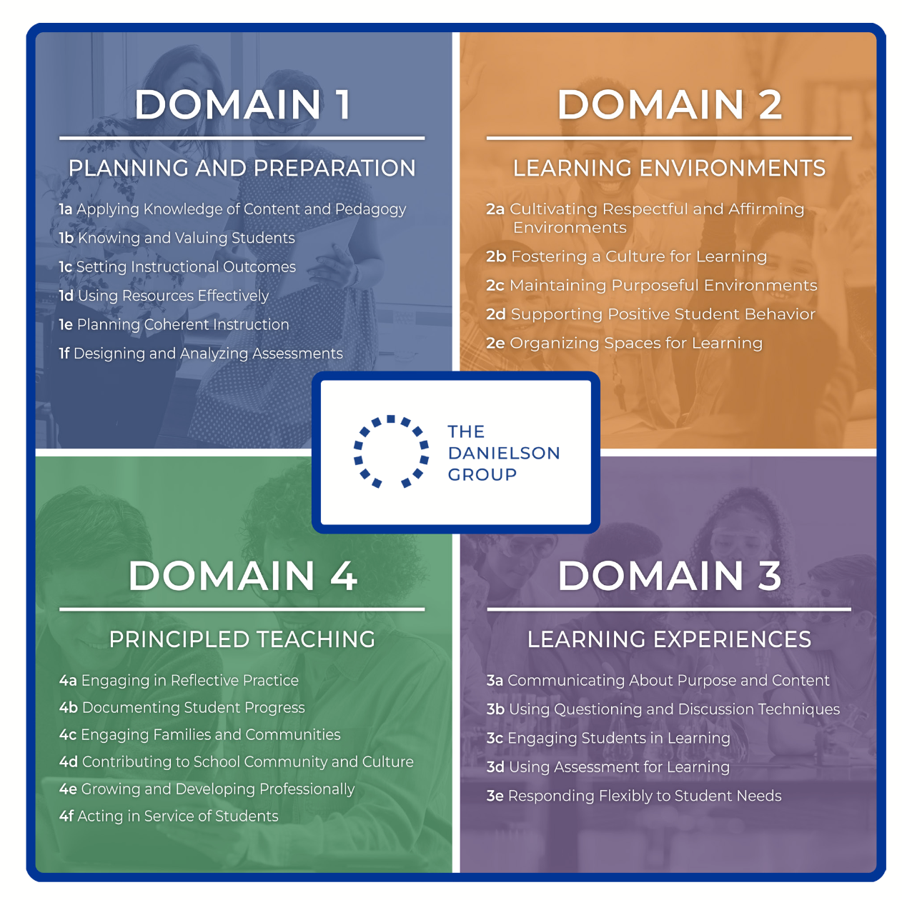
Name:
Grade:
Subject:
School:
District:

Resources:
Danielson Framework for Teaching (in-depth descriptions and information)
Framework for Teaching At-A-Glance (learn more)

Beginning of the Year

Self-Evaluation

Name three strengths you have as a teacher:

Name one thing you would like to improve upon this year:

Goal 1:

Identify Domain and Component: (e.g.. 2c, 3d)

How will your learning increase from achieving this goal?

Action Steps  (Specific Principal/Teacher/Specialist Professional Activities) | Resources  (Staff, PD, or Materials) | Evidence  (Timeframe for Action Steps/Activities to be Completed) | Timeline  (Initial and Date as Each Action Step/Activity is Completed)

Evidence (How will you know if the goal has been accomplished and what artifacts will you use to show the goal was accomplished): (include attachments: videos, pics, student work, etc.)

Midyear Update (What progress has been made towards meeting the goal? What revisions to the IPLP are necessary?) (include attachments: videos, pics, student work, etc.)

Summative Update (Was the goal accomplished? How do the artifacts support this conclusion?) (include attachments: videos, pics, student work, etc.)

Goal 2:

Identify Domain and Component: (e.g.. 2c, 3d)

How will your learning increase from achieving this goal?

Action Steps  (Specific Principal/Teacher/Specialist Professional Activities) | Resources  (Staff, PD, or Materials) | Evidence  (Timeframe for Action Steps/Activities to be Completed) | Timeline  (Initial and Date as Each Action Step/Activity is Completed)

Evidence (How will you know if the goal has been accomplished and what artifacts will you use to show the goal was accomplished): (include attachments: videos, pics, student work, etc.)

Midyear Update (What progress has been made towards meeting the goal? What revisions to the IPLP are necessary?) (include attachments: videos, pics, student work, etc.)

Summative Update (Was the goal accomplished? How do the artifacts support this conclusion?) (include attachments: videos, pics, student work, etc.)

Goal 3:

Identify Domain and Component: (e.g.. 2c, 3d)

How will your learning increase from achieving this goal?

Action Steps  (Specific Principal/Teacher/Specialist Professional Activities) | Resources  (Staff, PD, or Materials) | Evidence  (Timeframe for Action Steps/Activities to be Completed) | Timeline  (Initial and Date as Each Action Step/Activity is Completed)

Evidence (How will you know if the goal has been accomplished and what artifacts will you use to show the goal was accomplished): (include attachments: videos, pics, student work, etc.)

Midyear Update (What progress has been made towards meeting the goal? What revisions to the IPLP are necessary?) (include attachments: videos, pics, student work, etc.)

Summative Update (Was the goal accomplished? How do the artifacts support this conclusion?) (include attachments: videos, pics, student work, etc.)

