Cu-67 Specification

High Specific Activity & High purity
Half Life | 2.58 days
Decays | Zn-67 stable
Significant emissions | Beta : 580 keV Gamma : 184.6 keV
Form | CuCl2
Available | Solution 0.01 M HCl
Concentration | 300 mCi/mL  11.1 GBq/mL
Specific Activity | > 50 Ci/mg  typically >200 Ci/mg;  1.48 - 7.40 TBq/mg
Radionuclidic Purity | >99.9% Cu-67
Calibration date | 24 hrs from process end date
Expiry date | 10 days post- calibration date
Availability | Weekly
Batch Size | 50-200 mCi;  1.85-7.4 GBq  Available in larger batches on request
Packaging | 1ml conical screw top vial
Research Grade | Not for Human Use

Cu-67


e-Linac produced Research Grade Product


Idaho Accelerator Center
1500 Alvin Ricken Drive, Pocatello, ID 83201, USA

Contact: Jon Stoner Ph: +1 208 282 587
Email: stonjon@isu.edu

e-Linac Cu-67
Typical Gamma Spectrum of e-Linac Cu-67


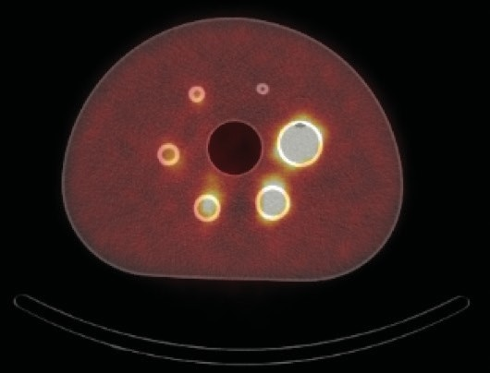
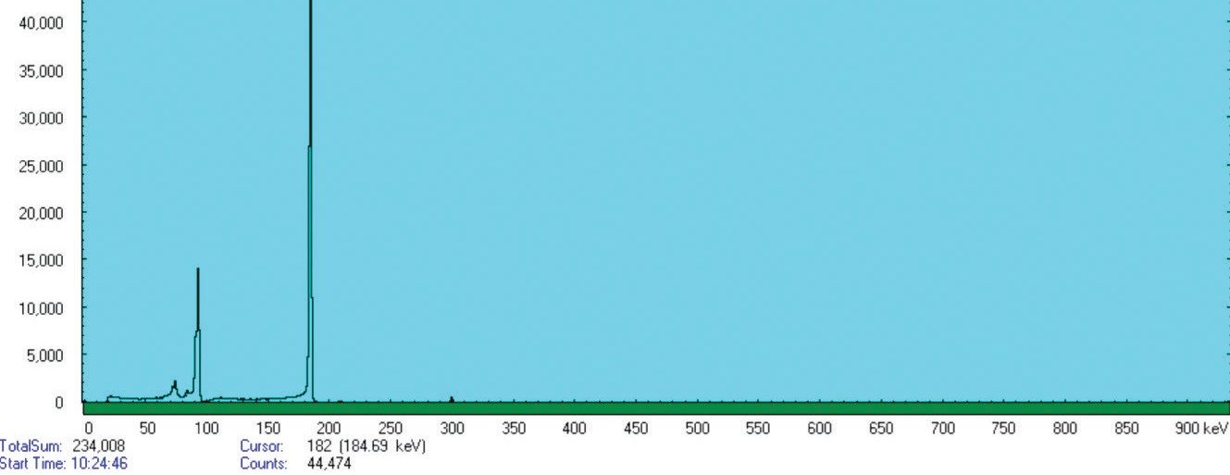
Cu-67 is an ideal radionuclide for therapy in oncology. For radiopharmaceutical devel- opment it forms the perfect ‘theranostic pairing’ with Cu-64, used for PET imaging. The gamma emissions of Cu-67 also enable surrogate SPECT imaging over 10 days.
Counts

Historically, Cu-67 has been produced on high-energy proton accelerators. Unfortu- nately, low specific activity, poor availability and co-production of Cu-64 and other ra- dionuclides have limited its widespread use.

Energy (keV)

Percentage of e-Linac Cu-67 activity remaining after EOB


Figure 1: SPECT CT image of Cu-67 phantom (Royal North Shore Hospital, Sydney, Australia)
 | Hours since activation
Days since activation |  | 0 | 3 | 6 | 9 | 12 | 15 | 18 | 21
Days since activation | 0 | 100% | 97% | 93% | 90% | 87% | 85% | 82% | 79%
Days since activation | 1 | 76% | 74% | 71% | 69% | 67% | 65% | 62% | 60%
Days since activation | 2 | 58% | 56% | 55% | 53% | 51% | 49% | 48% | 46%
Days since activation | 3 | 45% | 43% | 42% | 40% | 39% | 38% | 36% | 35%
Days since activation | 4 | 34% | 33% | 32% | 31% | 30% | 29% | 28% | 27%
Days since activation | 5 | 26% | 25% | 24% | 24% | 23% | 22% | 21% | 21%
Days since activation | 6 | 20% | 19% | 19% | 18% | 17% | 17% | 16% | 16%
Days since activation | 7 | 15% | 15% | 14% | 14% | 13% | 13% | 12% | 12%
Days since activation | 8 | 12% | 11% | 11% | 10% | 10% | 10% | 9% | 9%
Days since activation | 9 | 9% | 9% | 8% | 8% | 8% | 7% | 7% | 7%

Today, e-linac production of Cu-67 [using the photonuclear reaction 68Zn(y,p) 67Cu] is cleaner and has a ‘game changing’ higher specific activity (50 – 100 times greater). than Cu-67 produced via other nuclear reactions and high purity (>99% radionuclidic purity).
Expiry times are also longer.

